**5-Aug-2024**

**Internship Day - 15 Report:**

**Step-by-Step Guide to Upload a Website Online Using Apache Server on Ubuntu**

**1. Install Apache2**

* Open the terminal on your Ubuntu server and run the following command to install Apache2:



* This command installs the Apache web server. By default, Apache starts automatically after installation.

**2. Access the Apache Server**

* Copy the public IP address of your instance and paste it into your web browser. You should see the Apache2 default welcome page, indicating that the server is running correctly.

**3. Navigate to the Web Directory**

* In the terminal, change the directory to the default web root for Apache:

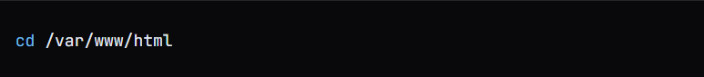

* This is where you will upload your website files.

**4. Install PHP**

* To enable PHP support for your web applications, install PHP by running:



* This command installs PHP and its necessary modules.

**5. Install MySQL**

* Next, install the MySQL server to manage your databases:  
    
  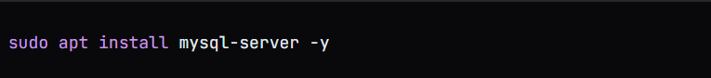

**6. Access MySQL**

* To access the MySQL prompt, use the following command:  
    
  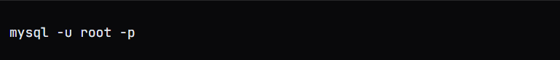
* Alternatively, you can use:

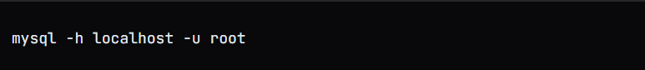

**7. Set MySQL Root Password**

* Once logged in to MySQL, set a password for the root user by executing:  
    
  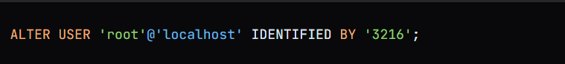

**8. Create a Database**

* Show existing databases and create a new database for your application:

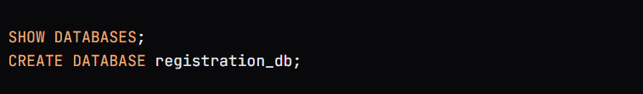

* Replace registration_db with your desired database name.

**9. Use the Database**

* Select the database you just created:  
    
  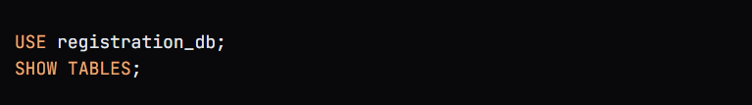
* You can now create tables or import data into this database.

**10. Upload Files Using FileZilla**

* Open FileZilla and connect to your server using your .pem key file:

1. **Host**: Your server's IP address
2. **Username**: ubuntu
3. **Authentication**: Use your .pem file

* Upload your SQL file to the /var/www/html directory through FileZilla.

**11. Change Ownership of the Web Directory**

* After uploading your files, change the ownership of the /var/www/html directory to ensure that the ubuntu user has the necessary permissions:  
    
  
* This command recursively changes the ownership of the directory.

**12. Import the SQL File**

* To import the SQL file into your database, run the following command in the terminal:  
    
  mysql -h localhost -u root -p registration_db < /var/www/html/registration_db.sql
* This command imports the SQL file into the registration_db database.

**13. Verify Database Content**

* To check the contents of your database, log in to MySQL again and run:  
    
  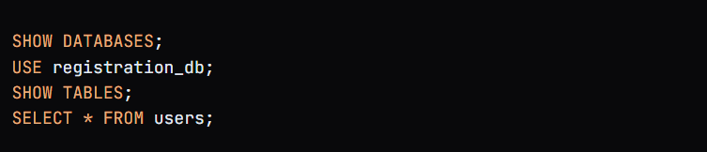
* This will display the tables and data within the users table.

**14. Upload PHP Files**

* Using FileZilla, upload your PHP files to the /var/www/html directory. Ensure that your PHP files are correctly placed and configured to connect to your database.

**15. Configure Apache Virtual Host**

* Finally, change the configuration for your website by editing the 000-default.conf file:

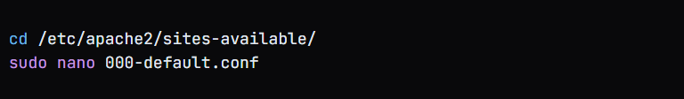

* Modify this file to set the DocumentRoot or any other configurations necessary for your site.

**6-Aug-2024**

**Internship Day - 16 Report:**

**Step-by-Step Guide to Manage MySQL Users and Configure PHP on Apache Server**

**1. Check User Information in MySQL**

* To view the current users and their hosts, run the following command in the MySQL prompt:



**2. View User Authentication Details**

* To see more detailed information about users, including their authentication strings, execute:



**3. Check User Authentication Plugin**

* To view the authentication plugin used by each user, run:



**4. Create a New MySQL User**

* To create a new user named chandan with a password, use the following command:



**5. Grant Privileges to the New User**

* To grant all privileges on the registration_db database to the new user, execute:



**6. Flush Privileges**

* To ensure that MySQL recognizes the changes made to user privileges, run:



* This command clears any cached privileges and reloads the user permissions.

**7. Change Database Credentials in PHP File**

* Open your PHP file using vim or any text editor to update the database username and password for the connection. For example:



* Change the credentials in the connection string to reflect the new user chandan and the password '123'.

**8. Check Apache Error Logs**

* To monitor the Apache error logs in real-time for any issues, use the following command:



This will display the latest error messages, helping you troubleshoot any problems with your web application.

**7-Aug-2024**

**Internship Day - 17 Report:**

**Define Firewall**

* **Firewall**: Protects a network by controlling incoming and outgoing traffic based on predetermined security rules. Requires knowledge of port numbers to control access.

**OSI (Open System Interconnection) Model**

* **Application Layer**: Handles human-computer interaction, where applications access network services.
* **Presentation Layer**: Ensures data is in a usable format and handles encryption.
* **Session Layer**: Maintains and controls sessions and ports.
* **Transport Layer**: Transmits data using transmission protocols, TCP and UDP.
* **Network Layer**: Determines the path for data transmission.
* **Data Link Layer**: Defines the data format for transmission over the network.
* **Physical Layer**: Deals with hardware (processor, RAM, HDD).

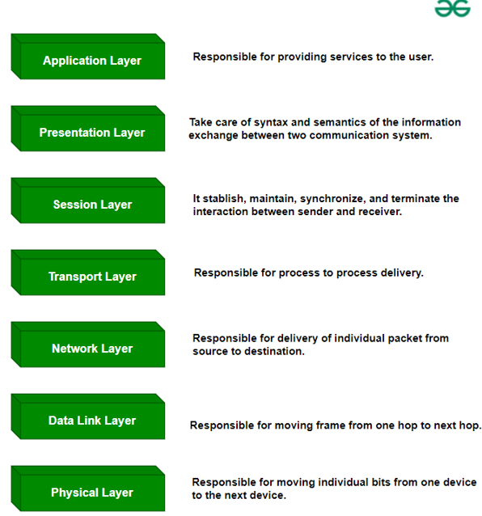

**Protocols**

* **Protocols**: A set of rules and regulations governing data exchange.  
  + **Application, Presentation, Session Layers**: Associated with port numbers.
  + **Transport Layer**: Involves TCP/IP and UDP protocols.
  + **UDP**: Used for small queries (e.g., DNS).
  + **TCP**: Used for larger work/queries or requests.

**DNS in AWS (Route 53)**

* **AWS Route 53**: Manages DNS, mapping domain names to IP addresses.
* **Domain Name Website**: Paste DNS information to link a domain name to AWS.

**Ports and Their Functions**

* **SSH**: Port 22
* **MySQL**: Port 3306
* **HTTPS**: Port 443
* **SMTP**: Port 25
* **HTTP**: Port 80
* **POP3**: Port 995
* **RDP**: Port 3389
* **FTP**: Port 21 (data) and 20 (command)
* **POP2**: Port 109
* **DNS**: Port 53

**Role of Port Numbers in Firewalls**

* Port numbers help block or allow traffic through the firewall by controlling access based on protocol and destination.

**Network Layer and Data Link Layer**

* **Network Layer**: Uses IP addresses to route data.
* **Data Link and Physical Layer**: Handles network connections via WiFi, LAN, or WAN.

**Client-Server Communication**

* Example: **Client** (IP and port 192.168.1.1:3306) sends a request to **Server**.

**Ping of Death Attack**

* A **DOS (Denial of Service)** attack where excessive ping requests overload the network, particularly through UDP protocol due to its small request size.

**8-Aug-2024**

**Internship Day - 18 Report:**

**Topics in Firewall**

* 1. What is a Firewall?
  2. Firewalld service in Linux
  3. Enable/disable Firewall
  4. How to see the existing firewall rules
  5. Adding & deleting Firewall Rules
  6. Adding/Removing Ports
  7. Block incoming/outgoing Traffic
  8. Block ICMP

**Types of Firewall:**

1. **Software Firewall:** A software firewall is installed on individual devices, such as computers or servers, and monitors incoming and outgoing traffic at the software level. It’s more flexible and often suitable for individual or small network protection.
2. **Hardware Firewall:** A hardware firewall, on the other hand, is a physical device placed between a network and external traffic sources, providing a strong barrier for larger networks. It offers robust protection for enterprise environments, managing traffic before it reaches internal devices.

**Make a Linux instance in AWS and access through xfreedp in linux:**

### 1. Basic Setup and Initial Configuration

#### **Installing Apache with Firewall Protection:**

# Install Apache  
sudo apt install apache2 -y  
  
# Install firewalld  
sudo apt install firewalld -y  
  
# Start and enable firewalld  
sudo systemctl start firewalld  
sudo systemctl enable firewalld  
  
# Verify installations  
apache2 -v  
firewall-cmd --version

### 2. Common Firewall Scenarios

#### **Scenario 1: Setting Up a Web Server**

# Allow HTTP and HTTPS  
sudo firewall-cmd --zone=public --add-service=http --permanent  
sudo firewall-cmd --zone=public --add-service=https --permanent  
sudo firewall-cmd --reload  
  
# Verify configuration  
curl localhost

#### **Scenario 2: Database Server Setup**

# Allow MySQL  
sudo firewall-cmd --zone=public --add-port=3306/tcp --permanent  
sudo firewall-cmd --reload  
  
# Test MySQL connection  
telnet localhost 3306

### 3. Advanced Service Management

#### **Working with Custom Services**

# Create new service  
sudo firewall-cmd --new-service=myapp --permanent  
  
# Configure service  
sudo firewall-cmd --service=myapp --add-port=8080/tcp --permanent  
sudo firewall-cmd --zone=public --add-service=myapp --permanent

#### **Multiple Port Configuration**

# Add port range  
sudo firewall-cmd --zone=public --add-port=4000-4100/tcp --permanent  
  
# Add multiple individual ports  
sudo firewall-cmd --zone=public --add-port=8080/tcp --add-port=8443/tcp --permanent

### 4. Security Hardening Examples

#### **Blocking Suspicious IP Addresses**

# Block single IP  
sudo firewall-cmd --permanent --add-rich-rule='rule family="ipv4" source address="10.10.10.10" reject'  
  
# Block IP range  
sudo firewall-cmd --permanent --add-rich-rule='rule family="ipv4" source address="192.168.1.0/24" reject'

#### **Rate Limiting**

# Limit SSH connections  
sudo firewall-cmd --permanent --add-rich-rule='rule service name="ssh" accept limit value="3/m"'

### 5. Real-World Applications

#### **Setting Up a LAMP Stack**

# Allow required services  
sudo firewall-cmd --zone=public --add-service=http --permanent  
sudo firewall-cmd --zone=public --add-service=https --permanent  
sudo firewall-cmd --zone=public --add-port=3306/tcp --permanent  
sudo firewall-cmd --reload  
  
# Verify configuration  
sudo firewall-cmd --list-all

#### **Securing Remote Access**

# Configure SSH access  
sudo firewall-cmd --zone=public --add-service=ssh --permanent  
  
# Allow specific IP for SSH  
sudo firewall-cmd --permanent --add-rich-rule='rule family="ipv4" source address="trusted-ip" service name="ssh" accept'

### 6. Monitoring and Troubleshooting

#### **Real-time Monitoring**

# Watch active connections  
watch -n1 "sudo firewall-cmd --list-connections"  
  
# Monitor rejected packets  
sudo tail -f /var/log/messages | grep REJECT

#### **Common Issues and Solutions**

##### **Problem 1: Service Not Accessible**

# Check if service is allowed  
sudo firewall-cmd --list-services  
  
# Verify port is open  
sudo firewall-cmd --list-ports  
  
# Test port locally  
nc -zv localhost <port>

##### **Problem 2: Website Blocking Not Working**

# Clear DNS cache  
sudo systemd-resolve --flush-caches  
  
# Verify rich rules  
sudo firewall-cmd --list-rich-rules  
  
# Test blocking  
ping blocked-website.com

### 7. Advanced Configurations

#### **Custom Zone Configuration**

# Create custom zone  
sudo firewall-cmd --permanent --new-zone=customzone  
  
# Configure zone  
sudo firewall-cmd --zone=customzone --add-service=http --permanent  
sudo firewall-cmd --zone=customzone --add-source=192.168.1.0/24 --permanent

#### **Time-Based Rules**

# Allow service during business hours  
sudo firewall-cmd --permanent --add-rich-rule='rule family="ipv4" service name="http" accept time start="9:00" end="17:00"'

### 8. Backup and Recovery

#### **Backup Configuration**

# Export configuration  
sudo firewall-cmd --runtime-to-permanent  
sudo cp -r /etc/firewalld /etc/firewalld.bak  
  
# Restore configuration  
sudo cp -r /etc/firewalld.bak/* /etc/firewalld/  
sudo systemctl restart firewalld

### 9. Regular Maintenance Tasks

#### **Weekly Maintenance Checklist**

# 1. Check firewall status  
sudo firewall-cmd --state  
  
# 2. Review active rules  
sudo firewall-cmd --list-all  
  
# 3. Check logs for suspicious activity  
sudo journalctl -u firewalld --since "24 hours ago"  
  
# 4. Verify services  
sudo firewall-cmd --list-services  
  
# 5. Update firewall  
sudo apt update  
sudo apt upgrade firewalld

### 10. Performance Optimization

#### **Optimize Rule Processing**

# Remove redundant rules  
sudo firewall-cmd --remove-rich-rules='rule family="ipv4" source address="0.0.0.0/0" accept'  
  
# Organize rules by frequency  
# Most used rules should be at the top  
sudo firewall-cmd --permanent --add-rich-rule='rule priority=1 service name="http" accept'

**9-Aug-2024**

**Internship Day - 19 Report:**

**Comprehensive Firewall Management Guide Continue**

apt install apache2  
  
service apache2 status  
  
apt install firewalld –y

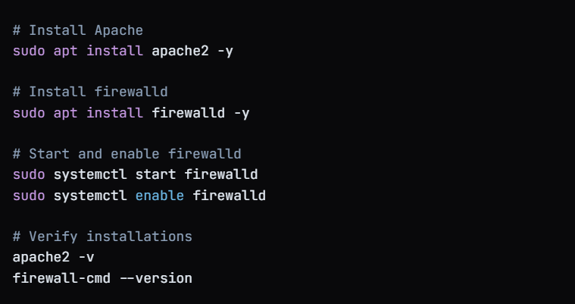  
  
ping gndec.ac.in  
  
**For Block a website temporary :**  
  
firewall-cmd --direct --add-rule ipv4 filter OUTPUT 0 -d 175.176.187.102 -j DROP  
  
**To check list which website has been blocked :**

iptables -t filter -L -v -n  
  
**For UnBlock a website temporary:**firewall-cmd --direct --remove-rule ipv4 filter OUTPUT 0 -d 175.176.187.102 -j DROP  
  
**OR**firewall-cmd –reload  
  
**For Block a website Permanent :**  
firewall-cmd --direct --remove-rule ipv4 filter OUTPUT 0 -d 175.176.187.102 -j DROP